Variable Tooltips

While variable operations don’t normally create any tooltips, it’s possible to add them manually via the tooltip parameter.

add_to_variable = {
var_monthly_population = 0.05
tooltip = monthly_population_tooltip
}
add_to_variable = {
var_max_efficiency = 0.05
tooltip = max_efficiency_tooltip
}

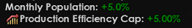

The tooltips’ loc entries use two hardcoded tokens:

- $LEFT$ holds the variable’s pre-operation value
- $RIGHT$ is the value being added to/subtracted to/multiplying/dividing the variable

Both of those can be formatted with the same parameters as variables, placed after a | before the second $ character:

monthly_population_tooltip:0 "Monthly Population: $RIGHT|+=%1$"
max_efficiency_tooltip:0 "£prod_eff_cap Production Efficiency Cap: $RIGHT|+=%$"

All of the effects in the list below have been confirmed to accept tooltip parameters:

set_variable
set_temp_variable
add_to_variable
add_to_temp_variable
subtract_from_variable
subtract_from_temp_variable
multiply_variable
multiply_temp_variable
divide_variable
divide_temp_variable
In the case of set_variable, $LEFT$ will be the previous value of the variable being reset, and $RIGHT$ the new one.
For set_temp_variable, both $LEFT$ and $RIGHT$ have the same value.

Examples:
set_variable = {
test_var = 2
tooltip = set_var_tooltip
}
set_temp_variable = {
test_var = 2
tooltip = set_var_tooltip_temp
}

set_var_tooltip:0 "Sets test_var to $RIGHT$. Previous value = $LEFT$."
set_var_tooltip_temp:0 "Sets temp test_var to $RIGHT$."

set_var_tooltip:0 "Sets test_var to $RIGHT|G0$. Previous value = $LEFT|R0$."
set_var_tooltip_temp:0 "Sets temp test_var to $RIGHT|G0$."

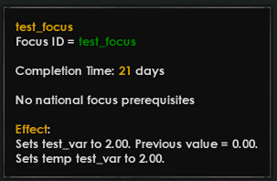 | 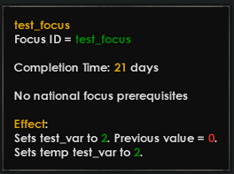

add_to_variable = {
test_var = 2
tooltip = add_to_var_tooltip
}
add_to_temp_variable = {
test_var = 2
tooltip = add_to_var_tooltip_temp
}

add_to_var_tooltip:0 "Adds $RIGHT|G0$ to test_var (value = $LEFT|G0$)."
add_to_var_tooltip_temp:0 "Adds $RIGHT|G0$ to temp test_var (value = $LEFT|G0$)."

